

**ENGINEERING CLINICS**

SUBMITTED TO: **PROF.VINOD KIRAN**

SUBMITTED BY:

SOURABH JAIN (22BCE8428)

ARGHYABIR SAHA (22BCE9309)

SHUBHAM KUMAR BIND (22BCE8442)

HARSHIL DHOOT (22BCE9396)

YAMAN SHARMA (22BME7009)

SUKANT SAUMYA (22BCE8588)

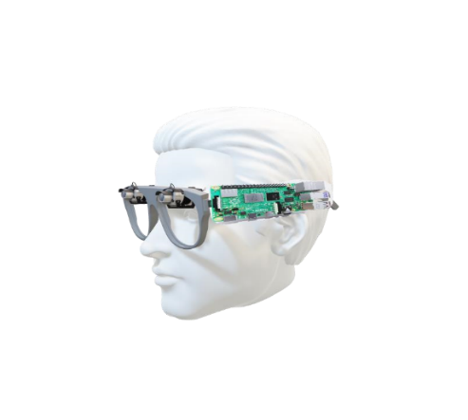

**TITLE:**

VISUAL READ ASSIST

Content

* Introduction
* Problem Identification
* Objective
* Procedure
* Components
* Project summary
* Future scope
* Reference
* Codes and appendix

**INTRODUCTION**

Visual Read Assist is a revolutionary tool designed to aid individuals with visual impairments. Leveraging advanced image recognition technology, it converts visual information into accessible formats. By providing real-time audio descriptions and tactile feedback, Visual Read Assist aims to enhance the independence and accessibility of blind individuals, facilitating a more inclusive and empowered experience in their daily lives.

The user-friendly interface ensures ease of use, making Visual Read Assist a practical and invaluable companion for individuals with visual impairments. By breaking down barriers to information and environment comprehension, this innovative device signifies a significant step toward creating a more inclusive and accessible world for those who are visually challenged. In essence, Visual Read Assist embodies the marriage of technology and compassion, aiming to redefine the possibilities for those navigating the world without sight.

Visual Read assist is related to visual assistance or reading technology, it could involve features or tools designed to aid individuals in visually consuming and understanding textual information. This might include technologies like optical character recognition (OCR), text-to-speech conversion, or other accessibility features.

**PROBLEM IDENTIFICATION**

Many individuals with visual impairments face significant challenges in accessing and analysing text-based information from their surroundings. According to the World Health Organization, approximately 253 million people worldwide are visually impaired, with limited access to written content.

While Braille and screen readers exist, they have limitations in terms of accessibility and convenience, creating a need for innovative solutions.

Addressing this problem not only enhances the quality of life for visually impaired individuals but also promotes inclusivity and equal access to information, education, and employment opportunities`

**OBJECTIVE**

The objective of our project on visual read assist for the blind using Raspberry Pi is to develop a wearable device that utilizes Raspberry Pi technology to capture images, convert text to speech, and provide real-time auditory assistance to blind individuals. This device aims to empower blind individuals with independent access to information, navigation, and education, enhancing their quality of life and promoting their independence.

* Image Capture: The device should effectively capture images using the Raspberry Pi camera, ensuring clear and accurate visual input.
* Optical Character Recognition (OCR): The device should accurately convert captured images into text, handling various fonts, sizes, and lighting conditions.
* Text-to-Speech (TTS) Conversion: The device should produce high-quality, natural-sounding speech output, enabling blind individuals to understand the text content.
* Real-time Audio Feedback: The device should provide real-time auditory feedback, allowing blind individuals to receive information as it is captured and processed

**PROCEDURE**

Blind Reader is a portable, low-cost, reading device made for the blind people. The Braille machines are expensive and as a result are not accessible to many.

Blind Reader overcomes the limitation of conventional Braille machine by making it

affordable for the common masses. The system uses OCR technology to convert images into text and reads out the text by using Text-to-Speech conversion.

The system supports audio output via Speakers as well as headphone. The user also has the ability to pause the audio output whenever he desires. It also has the facility to store the images in their respective book folder, thereby creating digital backup simultaneously.

With this system, the blind user does not require the complexity of Braille machine to read a book. All it takes is a button to control the entire system.

**COMPONENTS**

|  |  |
| --- | --- |
| **Hardware Requirements:** | **Software Requirements:** |
| ❑ Raspberry pie 4  ❑ 5mp Pi Camera  ❑ Speakers/Headphones  ❑ Spectacles  ❑ Power supply  ❑ Push button  ❑ RP Case | ❑ Python 3.  ❑ OS :Raspbian OS  ❑ Libraries required to be installed –  picamera2 , libcamera , os and time , PIL  , pytesseract , tesseract ocr , espeak . |

**PROJECT SUMMARY**

This project aims to develop a visual read assist device for blind individuals using a Raspberry Pi and a camera. The device will capture images using the camera, convert the images into text using optical character recognition (OCR) technology, and then synthesize the text into speech using a text-to-speech.

This will allow blind individuals to read text from physical documents or digital displays without relying on Braille or screen readers.

* **Project Objectives**
* Develop a low-cost, portable visual read assist device using a Raspberry Pi and a pi camera and a speaker.
* Implement OCR technology to accurately convert images of text into machine-readable text.
* Integrate text to speech to synthesize text into natural-sounding speech.
* Design a user-friendly interface for easy operation and navigation.
* **Project Significance**

This project has the potential to significantly improve the lives of blind individuals by providing them with a convenient and accessible way to read text. The device could be used in a variety of settings, such as schools, libraries, and workplaces, to help blind individuals achieve their academic and professional goals. Additionally, the device could be used for personal reading and communication, promoting greater independence and social inclusion.

* **Project Methodology**

STEP 1 : Installing libraries and OS

<https://www.raspberrypi.org/>

https://pypi.org/

STEP 2 : Connecting hardware

Pi Camera --> Camera Slot in Raspberry Pi 4.

Pair Bluetooth Speaker / Insert headphone into Raspberry Pi 4 audio jack.

STEP 3 : Embedding Python code

The project will be conducted in the following phases:

Setup: The Raspberry Pi and camera will be assembled and configured to capture images and process data.

OCR Integration: An OCR library will be integrated into the Raspberry Pi to convert captured images into text.

Testing and Evaluation: The device will be tested in real-world to evaluate its performance and usability.

* **Expected Outcomes**

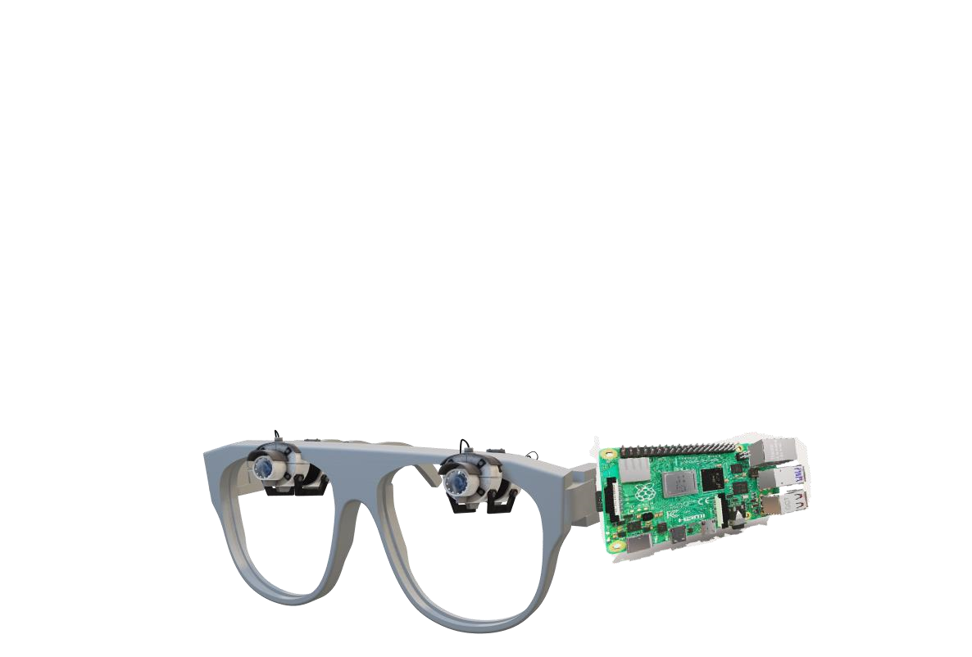

The project is expected to deliver the following outcomes:

* A fully functional visual read assist device using a Raspberry Pi and a camera.
* Accurate OCR conversion of images into text
* Natural-sounding of text into speech.
* A user-friendly interface for easy operation and navigation.
* Positive feedback from blind users regarding the device's usability and effectiveness.

**FUTURE SCOPE**

**Advanced OCR and Language Support:**

* Enhance Optical Character Recognition (OCR) capabilities to support a broader range of languages and writing systems.
* Implement machine learning algorithms for improved accuracy in recognizing diverse fonts, handwriting styles, and document formats.

**Multi-Modal Integration:**

* Integrate with various hardware and software platforms, including smart glasses, mobile devices, and computers, to offer a seamless multi-modal reading experience.
* Explore the integration of augmented reality (AR) to overlay information directly onto the user's field of view.

**Contextual Understanding:**

* Develop algorithms that understand the context of the text being read, enabling more accurate interpretation and contextual awareness.
* Incorporate natural language processing (NLP) techniques to understand and interpret the meaning behind the text.

**Personalization and User Preferences:**

* Implement features that allow users to customize their reading experience based on preferences such as reading speed, voice, and language.
* Utilize machine learning to adapt to individual user behaviors and continually improve the reading experience.

**Accessibility and Inclusivity:**

* Focus on making the VisualRead assist platform accessible to individuals with diverse needs, including those with visual impairments or learning disabilities.
* Explore partnerships with organizations and communities to gather feedback and ensure inclusivity in design and functionality.

**Continuous Research and Development:**

* Establish a dedicated research and development team to stay at the forefront of technological advancements in visual assistance and reading technologies.
* Regularly update the platform with new features, improvements, and compatibility with emerging technologies.

**Global Outreach and Localization:**

* Expand the reach of VisualRead assist to a global audience by localizing the interface and content support for different regions.
* Collaborate with international organizations to address specific regional needs and challenges.

**REFERRENCE**

**CODE APPENDIX**

